**AWS Logon & Initial instance (for NodeJS REST API code )**

1. [**http://aws.amazon.com**](http://aws.amazon.com) **, then click “Sign In to the Console”**



* 1. **U:** [**marty@nwtstech.com**](mailto:marty@nwtstech.com) **P: {usual}**

1. EC2 – Virtual Servers
   1. 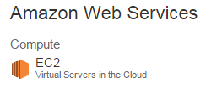
2. Click on Running Instances, Note: t1.micro instance type, named ‘Default-Environment’  
   IP: **54.69.52.11**, DNS: [http://**ec2-54-69-52-11.us-west-2.compute.amazonaws.com**](http://ec2-54-69-52-11.us-west-2.compute.amazonaws.com)

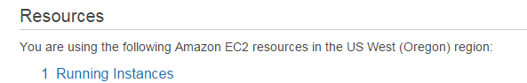

**NodeJS through Elastic Beanstalk**

1. RentalPropertyMinderAPI (rpminder-env)  
   URL: